The University of Azad Jammu and Kashmir , Muzaffarabad

Student Name: Sakeena Bano
Roll No: 2024-SE-29
Course Title: Database Systems
Course Code: CS-2204
Lab Instructor: Awais Rathore
Department: Software Engineering

Lab#0 9

Objective
The objective of this lab is to understand advanced SQL joins and use them to retrieve information from multiple related tables.
In this lab, I worked with SELF JOIN, multi-table joins, filtering, aggregation, and comparison conditions.

Learning Outcomes
After completing this lab, I was able to:
- Understand the concept of a SELF JOIN.
- Join a table with itself using aliases.
- Display employees and their managers.
- Compare an employee's salary with the manager's salary.
- Join three or more tables.
- Retrieve employee, project, and department information together.
- Compare department information between employees and projects.
- Use LEFT JOIN with filtering conditions.
- Use SUM and GROUP BY with joins.
- Work with multiple relationships in a single query.

Database Used
This lab uses the same Company database from Part A.
The database contains:
- Department
- Employee
- Project
- Assignment
The Employee table contains a ManagerID that refers back to another employee in the same table. This relationship allows a SELF JOIN to be performed.

SELF JOIN
A SELF JOIN occurs when a table is joined with itself.
In this database, the Employee table contains ManagerID. The value of ManagerID refers to another employee's EmpID.
Therefore, the Employee table can be treated as two separate copies:
- One copy represents the employee.
- The second copy represents the manager.
Table aliases are used to distinguish between the two copies.

Multi-table JOIN
A multi-table join combines information from three or more tables.
For example, to display an employee's name, project name, department name, and working hours, the Employee, Assignment, Project, and Department tables can be connected.
The joins are normally built step by step so that each relationship can be checked before adding another table.

Part B — Self Joins and Multi-table Joins
B1. Each employee with their manager
I displayed each employee together with the name of their manager.
A SELF JOIN was used because both employee and manager information is stored in the Employee table.
Top-level managers were also displayed with NULL as their manager.

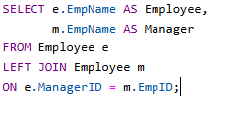
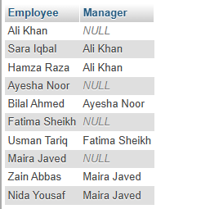
B2. Employees earning more than their manager
I compared the salary of each employee with the salary of their direct manager.
The result displayed the employee name, employee salary, manager name, and manager salary.

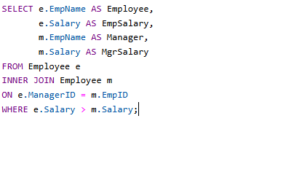
Null
B3. Employee and manager from different departments
I identified employees whose managers work in a different department.
The result displayed:
- Employee name
- Manager name
- Employee department
- Manager department

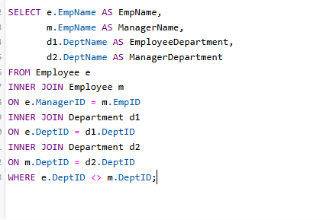
B4. Every employee with their projects and weekly hours
I displayed every employee together with the project they are working on and the number of hours they work on that project each week.
This required joining:
Employee → Assignment → Project

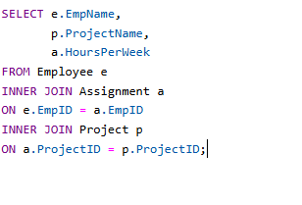
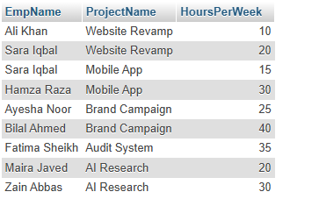

B5. Every assignment with employee, project and department
I displayed every assignment with:
- Employee name
- Project name
- Project department
- Hours per week
This task required four tables:
Employee → Assignment → Project → Department

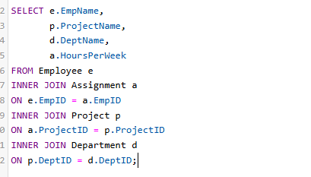
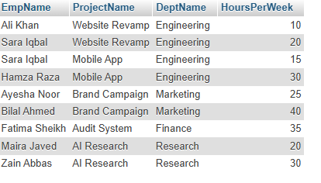

B6. Employees working on Mobile App
I displayed the employees working on the Mobile App project along with their weekly working hours.
A filter was applied to select only the Mobile App project.

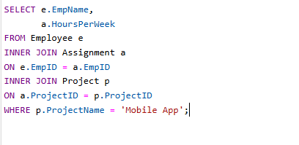
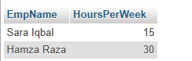
B7. Lahore employees with their projects
I displayed every employee from Lahore together with the projects assigned to them.
A LEFT JOIN was used so that Lahore employees without any project assignment were also included.

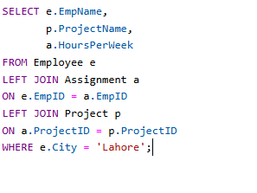
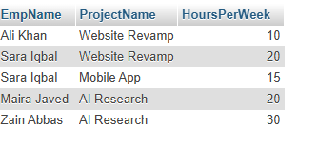
B8. Employees working on a project belonging to another department
I identified employees who work on projects that are managed by a department different from their own department.
The employee department ID and project department ID were compared.

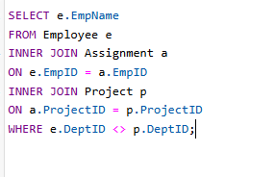
NULL

B9. Projects started in 2024 for every department
I displayed each department together with the projects that started in 2024.
A LEFT JOIN was used so that departments without qualifying projects were also included.
The date condition was applied as part of the join condition to preserve unmatched departments.

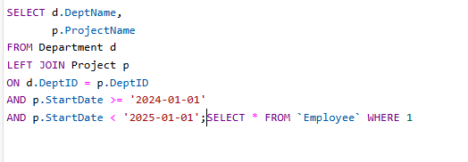
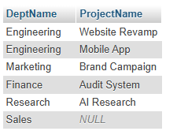
B10. Total weekly hours for every employee
I calculated the total number of hours each employee works per week across all assigned projects.
Employees with no project assignments were also included with zero total hours.
This task used:
- LEFT JOIN
- SUM

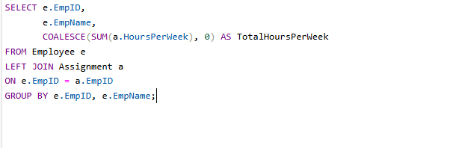
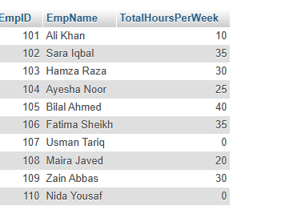
Important Observations
During this lab, I observed that:
- SELF JOIN is useful for hierarchical relationships.
- Table aliases are necessary when the same table is used more than once.
- Multiple tables can be joined together using related primary and foreign keys.
- LEFT JOIN can preserve records that do not have related data.
- GROUP BY can be used with joins to calculate totals.
- SUM can calculate the total working hours of employees.
- Conditions can be used to compare information between related tables.

Conclusion

- In this lab, I learned how to use advanced SQL joins to retrieve information from related
tables. I practiced SELF JOIN for employee-manager relationships and multi-table joins for employee, project, assignment, and department information.
- I also learned how joins can be combined with filtering, comparison, aggregation, and grouping to solve more complex database problems.

